**Investment Research Analysis**

Index

* Qualitative Analysis
  + Company Overview
  + Founders
  + Board of Directors
  + Executive Team
  + Ownership
  + Product Positioning
  + Competitive Analysis Globally

* Quantitative Analysis
  + 10K Research
  + Financials Since IPO
  + Current Balance Sheet
  + Capitalization requirements
  + Break-even analysis
  + Cash flow projections
  + Cash-flow Statement
  + Industry Average Valuation Multiples

* Stock Price Analysis
  + Stock Price Since IPO
  + Index Analysis

* Market Research
  + Target market research
  + SWOT analysis

* Mergers and Acquisitions

**Company Overview**

Galaxy Entertainment Group Limited (GEG), headquartered in Hong Kong, China, founded in 1988, is one of the world’s leading resorts, hospitality and gaming companies. It primarily develops and operates a large portfolio of integrated resort, retail, dining, hotel and gaming facilities in Macau. GEG is listed on the Hong Kong Stock Exchange and is a constituent stock of the Hang Seng Index. As of June 2023, the company owns about 17,000 employees.

GEG operates three flagship destinations in Macau: on Cotai, Galaxy Macau™, one of the world’s largest integrated destination resorts, and the adjoining Broadway Macau™, a unique landmark entertainment and food street destination; and on the Peninsula, StarWorld Macau, an award-winning premium property. These properties cater to different market segments, targeting both mass-market and high-end customers. GEG's properties are known for their exceptional quality, innovative design, and commitment to providing exceptional customer experiences.

GEG was founded by Che-Woo Lui in 1988. On Dec 1, 1998, it was acquired by Onex for an undisclosed amount. On Feb 5, 1999, GEG went public (hkg:0027). On Jul 22, 2005, Galaxy Entertainment Group acquired Galaxy Casino for an undisclosed amount. On Aug 11, 2006, Galaxy Entertainment Group acquired K. Wah Asphalt for an undisclosed amount. Galaxy Entertainment Group closed its last funding round on Oct 11, 2007 from a Post-IPO Equity round for a total of £420M.

**Founders**

Founder: Che-Woo Lui

In 1955, Che-Woo Lui founded K. Wah Construction Materials Limited, a construction materials company in Hong Kong. Over the years, he expanded his business interests and diversified into various industries, including real estate, hospitality, and entertainment. In 1988, Che-Woo Lui ventured into the gaming industry and established Galaxy Entertainment Group. At that time, Macau was transitioning from primarily textile manufacturing to a global gaming and entertainment destination. Under Che-Woo Lui’s leadership, Galaxy Entertainment Group steadily grew and became one of the major players in Macau's gaming industry. Nowadays, Galaxy Entertainment Group is still controlled by Che-Woo Lui and his family, which has a combined interest of 50.3%. This family has a direct interest of 8.6% in GEG and an indirect interest of 41.7% via the Lui Family Trust and Hong Kong listed K Wah International.

**Board of Directors**

**Che Woo Lui (Chairman):** Che Woo Lui is the founder of the Galaxy Entertainment Group, and has been a Director since August 1991 and is the Chairman and a member of the Executive Board. He is also the Chairman and the Managing Director of K. Wah International Holdings Limited. He has over 50 years’ experience in quarrying, construction materials and property development. He was the Founding Chairman of the Institute of Quarrying in the UK (Hong Kong Branch) and the Chairman of the Tung Wah Group of Hospitals (1981–1982). Dr. Lui is also the Founding Chairman of The Federation of Hong Kong Hotel Owners, the President of Tsim Sha Tsui East Property Developers Association, the Founding President of Hong Kong – Guangdong Economic Development Association and an Honorary President of the 8th Committee of Hong Kong – Shanghai Economic Development Association.

**Yiu Tung Lui (Executive Director):** Yiu Tung Lui joined the Group in 1979. He has been an executive Director since June 1987 and is the Deputy Chairman and a member of each of the Executive Board, Nomination Committee and Remuneration Committee as well as the Chairman of Corporate Governance Committee. Mr. Lui is also an executive director of K. Wah International Holdings Limited. He holds a bachelor of science degree in civil engineering and a master of science degree in structural engineering from the University of California at Berkeley, USA.

**Ying Keung Chee (Executive Director):** Ying Keung Chee joined the Group in 1982. He has been an executive Director since April 2004 and is the Managing Director of the Construction Materials Division as well as a member of the Executive Board. Mr. Chee holds a Master degree in Business Administration from the University of South Australia and a Bachelor degree in Mechanical Engineering from the University of Western Ontario in Canada. He has over 35 years of broad experience in the construction materials industry including operations and management, technical and quality assurance, environmental protection, commercial and strategic planning.

**Lui Wai Yu Tang (Executive Director):** Lui Wai Yu Tang joined the Group in 1980 and has been an executive Director since August 1991 as well as a member of the Executive Board. She is also an executive director of K. Wah International Holdings Limited. She holds a bachelor of commerce degree from McGill University, Canada and is a member of The Institute of Chartered Accountants in England and Wales.

**Wai Bun Cheung (Non-executive Director):** Wai Bun Cheung has been a non-executive Director since October 2015. Dr. Cheung is a member of each of the Audit Committee and Corporate Governance Committee of the Company. Dr. Cheung holds an honorary doctor’s degree from John Dewey University, U.S.A., a master degree in business administration and a bachelor of science degree in accounts and finance from New York University, U.S.A.

**James Ross Ancell (Independent Non-executive Directors):** James Ross Ancell has been an independent non-executive Director since April 2004. Mr. Ancell is the Chairman of the Audit Committee and a member of the Corporate Governance Committee of the Company. He holds a Bachelor’s degree in Management Studies from University of Waikato in New Zealand. He is a Fellow of Chartered Accountants Australia and New Zealand and has over 40 years of broad experience in building materials and construction sectors, waste management and recycling business gained from multinational corporations.

**Shue Lam Yip (Independent Non-Executive Director):** Shue Lam Yip has been an independent non-executive Director since December 2004. Dr. Yip is a member of the Audit Committee as well as the Chairman of the Nomination Committee and the Remuneration Committee of the Company. Dr. Yip holds a Bachelor of Arts degree and an honorary Doctor of Laws degree from the Concordia University, Canada. He is the founder and the chairman of Canada Land Limited (“Canada Land”) since 1972.

**Lung Tak Wong (Independent Non-Executive Director):** Lung Tak Wong has been an independent non-executive Director since August 2008. Professor Wong is a member of each of the Audit Committee, Remuneration Committee, Nomination Committee and Corporate Governance Committee of the Company. He is a Certified Public Accountant (Practicing) in Hong Kong and the Managing Practicing Director of Patrick Wong CPA Limited. He has over 50 years’ experience in the accountancy profession.

**Michael Victor Mecca (Independent Non-Executive Director):** Michael Victor Mecca was appointed as a non-executive Director in May 2018 and has been re-designated as an independent non-executive Director in March 2023. Prior to his appointment as non-executive Director, Mr. Mecca served the Group as President and Chief Operating Officer since 2009 and was the President of the Company from September 2015 until his retirement in April 2018. Mr. Mecca holds a Bachelor degree in Foreign Affairs from the University of Oklahoma in the USA. He held senior executive roles with a number of globally-recognized gaming and hospitality brands in Las Vegas and Melbourne.

**Jorge Neto Valente (Advisor):** Jorge Neto Valente is GEG’s Group Advisor and Galaxy Casino S.A.'s director.

Source: https://www.galaxyentertainment.com/en/aboutus/directors

**Executive Team**

**Che Woo Lui (Executive Chairman of the Board):** Che Woo Lui is an entrepreneur and businessperson who founded Galaxy Entertainment Group Ltd., K. Wah International Holdings Ltd., Lui Che Woo Prize Ltd. and Guangdong Economics Association and who has been the head of 11 different companies. He is Chairman & Managing Director at K. Wah International Holdings Ltd., Chairman at Galaxy Entertainment Group Ltd., Chairman of K. Wah Group, Founding President at Guangdong Economics Association, President for Tsim Sha Tsui East Property Developers Association Ltd. and Founding President at Hong Kong-Guangdong Economic Development Association. He is also Chairman of The Federation of Hong Kong Hotel Owners Ltd. and Chairman-Governors Board at Lui Che Woo Prize Limited. and on the board of 5 other companies. In his past career Dr. Lui held the position of Chairman at Stanford Hotels Corp., Chairman at Tung Wah Group of Hospitals and Founding Chairman at Institute of Quarrying.

**Yiu Tung Lui (Executive Deputy Chairman of the Board):** Yiu Tung Lui has been an executive Director since June 1987 and is the Deputy Chairman and a member of each of the Executive Board, Nomination Committee and Remuneration Committee as well as the Chairman of Corporate Governance Committee. Mr. Lui is also an executive director of K. Wah International Holdings Limited. He holds a bachelor of science degree in civil engineering and a master of science degree in structural engineering from the University of California at Berkeley, USA.

**Ying Keung Chee (Executive Director):** Ying Keung Chee has been an executive Director since April 2004 and is the Managing Director of the Construction Materials Division as well as a member of the Executive Board. Mr. Chee holds a Master degree in Business Administration from the University of South Australia and a Bachelor degree in Mechanical Engineering from the University of Western Ontario in Canada. He has over 35 years of broad experience in the construction materials industry including operations and management, technical and quality assurance, environmental protection, commercial and strategic planning

**Lui Wai Yu Tang (Executive Director):** Lui Wai Yu Tang has been an executive Director since August 1991 as well as a member of the Executive Board. She is also an executive director of K. Wah International Holdings Limited. She holds a bachelor of commerce degree from McGill University, Canada and is a member of The Institute of Chartered Accountants in England and Wales.

**Robert Drake (Group Chief Financial Officer):** Currently, Robert Charles Drake holds the position of Group Chief Financial Officer for Galaxy Entertainment Group Ltd. He received an undergraduate degree from Allegheny College and an MBA from the University of Rochester Simon Business School.

**James Houghton (Director-Information Systems & Technology):** Presently, James Houghton is Director-Information Systems & Technology at Galaxy Entertainment Group Ltd.

**Wai Ling Lui (Group Director-Human Resources & Administration):** Presently, Wai Ling Lui holds the position of Group Director-Human Resources & Administration at Galaxy Entertainment Group Ltd. She received an MBA from Richard Ivey School of Business and an undergraduate degree from the University of California, Los Angeles.

**Elmen Lee (SVP-Business Development & City Clubs Operations):** Elmen Lee is SVP-Business Development & City Clubs Operations at Galaxy Entertainment Group Ltd.

**Raymond Yin Min (Dir-International Premium & Mass Market Dev)**

Sources from: https://www.wsj.com/market-data/quotes/HK/XHKG/27/company-people/executive-profile/214835623

https://www.galaxyentertainment.com/en/aboutus/directors

**Ownership**

Ownership Breakdown

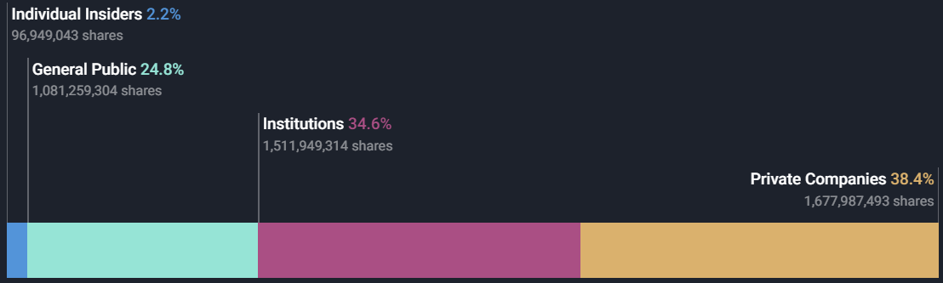

Top 25 shareholders own 70.08% of the company:

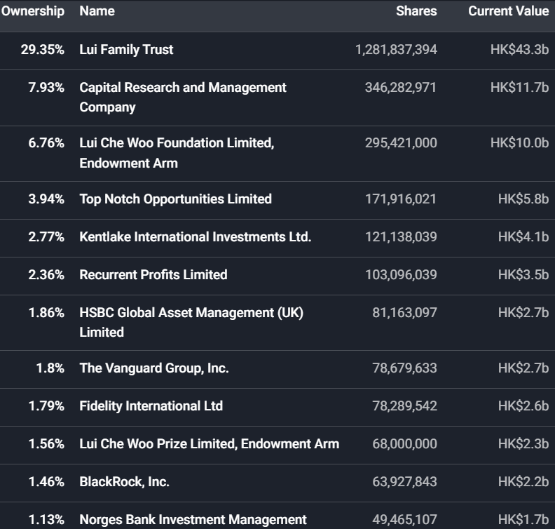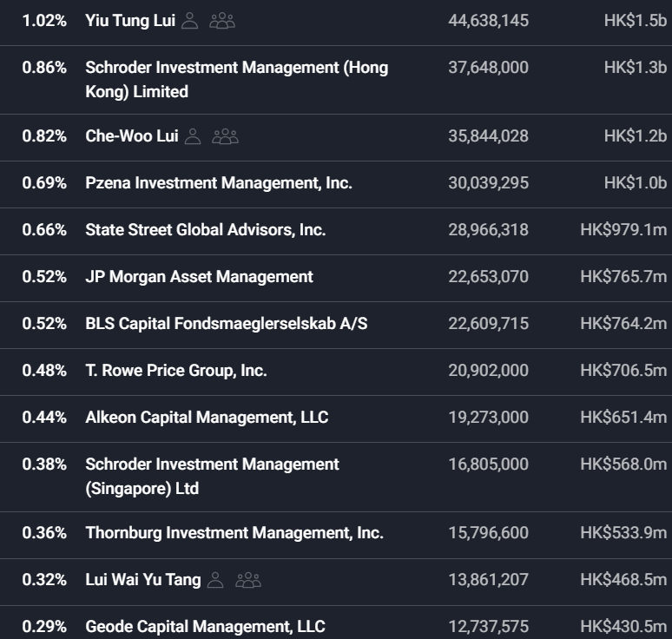

(Sources from: https://simplywall.st/stocks/us/consumer-services/otc-gxyy.y/galaxy-entertainment-group/ownership)

The Lui family trust owns 29.35% of Galaxy Entertainment Group. Lui Che Woo Foundation Limited, Endowment Arm owns 6.76%. Lui Che Woo Prize Limited, Endowment Arm owns 1.56%. This suggests that the founder's family has a substantial influence over the company's operations, decision-making, and strategic direction. With a significant ownership stake, Lui family trust may exert significant control over critical decisions, including board appointments, executive leadership, and major strategic initiatives. Moreover, it indicates the founder’s long-term commitment to the company's success.

Capital Research and Management Company, a wholly-owned subsidiary of The Capital Group Companies, owns 7.93% of GEG. Kentlake International Investments Ltd. Owns 2.77%. HSBC Global Asset Management (UK) Limited owns 1.86%. The Vanguard Group, Inc. owns 1.8%. Fidelity International Ltd owns 1.79%. BlackRock, Inc. owns 1.46%. Norges Bank Investment Management owns 1.13%. These investment firms and institutions’ substantial ownership suggests that GEG is attractive to professional investors.

Individual insiders own 2.2% of Galaxy Entertainment Group. Yiu Tung Lui (Executive Deputy Chairman of the Board), owns 1.02%, Che-Woo Lui (Founder and Executive Chairman of the Board), owns 0.82%, and Lui Wai Yu Tang (Executive Director), owns 0.32% of the company. Their ownership can be an indicator of alignment between management and shareholders' interests.

The general public owns 24.8% of GEG. It indicates that there is a large number of individual investors interested in GEG’s stock.

**Product Positioning**

Galaxy Entertainment Group's sustainable competitive advantage is based on a combination of its advanced business model, strong brand, prime location, operational excellence, and innovation. These characteristics create barriers for competitors to overcome and establish a solid position for GEG in the gaming and hospitality industry.

**Characteristics of Galaxy Entertainment Group**

* Advanced business model: Galaxy Entertainment Group's business model revolves around developing and operating integrated resorts, which include hotels, casinos, dining options, entertainment venues, and retail shops. This business model enhances the overall guest experience.
* Strong Brand: Galaxy Entertainment Group has established a strong brand reputation over the years. It is recognized for its high-quality resorts, exceptional customer service, and a commitment to providing a unique and memorable experience to its guests.

a) Galaxy Macau: Galaxy Macau is one of the flagship properties of Galaxy Entertainment Group. It has become synonymous with luxury, entertainment, and exceptional hospitality. The resort's brand is associated with high-quality experiences, attracting both local and international visitors.

b) StarWorld Hotel: StarWorld Hotel, another property under Galaxy Entertainment Group, has established itself as a reputable brand in Macau. It is known for its sophisticated design, top gaming facilities, and personalized service.

c) Broadway Macau: Broadway Macau is another flagship property of Galaxy Entertainment Group. It is an integrated resort that features a vibrant entertainment and shopping district. Broadway Macau offers live performances, street performances, retail outlets, and various dining options, creating an immersive and lively atmosphere.

* Prime Location: Galaxy Entertainment Group's integrated resorts are located in Macau, which is the center of the gaming and entertainment industry in Asia. This prime location provides an advantage in attracting customers and generating revenue.
* Operational Excellence: Galaxy Entertainment Group has operational excellence in managing its resorts and casinos. It focuses on providing high standards of service and maintaining clean and well-maintained facilities.
* Innovation: Galaxy Entertainment Group is known for its innovative designs and concepts in its resorts. It has a successful track record of delivering innovative, spectacular and award-winning properties, products and services.

Galaxy Entertainment Group was impacted by the COVID-19 pandemic like many companies in the gaming and hospitality industry. The travel restrictions, lockdowns, and social distancing measures resulted in a huge decline in visitor arrivals and thus, a significant decrease in GEG’s revenue and occupancy rates. But the negative impact was not unique to Galaxy Entertainment Group but affected the entire industry. As the pandemic situation improved and restrictions eased, Galaxy Entertainment Group gradually resumed operations and implemented safety protocols to provide a secure environment for visitors. With its competitive advantage, GEG has reported revenue of HK$7.05billion (US$901.8 million) in the first quarter of 2023, a 72.0% rise bolstered by the ending of Covid-19 restrictions in Macau.

Sources from: https://igamingbusiness.com/finance/quarterly-results/end-of-macau-restrictions-push-galaxy-entertainment-revenue-up-70/

**Competitive Analysis Globally**

**Asia:**

Sands China Ltd: It is a subsidiary of Las Vegas Sands Corp, a developer, owner, and operator of integrated resorts and casinos. The company operates casinos and games; develops integrated resorts and other ancillary services. It also provides hotel accommodations, retail outlet shopping, meeting rooms and theaters, restaurants and food outlets. Sands China offers medical treatments and spa services, providing convention center and ferry leasing services. Its hotel properties include The Venetian Macao-Resort-Hotel, Sands Macao, the Plaza Macao, and the Londoner Macao. The company also operates Cotai Expo, a convention and exhibition hall and Cotai Arena, an entertainment venue. Sands China is headquartered in Taipa, Macau Special Administrative Region of China.

Melco International Development Ltd: Melco’s operations spanned across the People’s Republic of China (the PRC), Macau, Hong Kong, the Philippines, and Cyprus. The company through its subsidiaries operates, owns, and develops casino gaming and entertainment resort facilities; it is involved in social gaming platforms development, slot machine participation business, and catering business. It also offers exclusive and sophisticated accommodations, dining services, and nightclubs.

SJM Holdings Limited: The company through its subsidiaries operates in China, Macau, and Hong Kong. It contains gaming and non-gaming operations. Its gaming operations include mass-market table gaming, VIP gaming, and slot machines and other electronic gaming machines. Its flagship casino is Casino Grand Lisboa and operates other self-promoted casinos and satellite casinos. SJM’s non-gaming operations include retail, hotel, catering, and related services. Its hotels include Grand Lisboa Palace Resort, Grand Lisboa Hotel, Jai Alai Hotel, and Sofitel Macau at Ponte 16.

Wynn Macau Ltd: It is a subsidiary of Wynn Resorts Ltd, develops, owns and operates integrated destination casino resorts in Macau. It owns and operates two casino resorts, namely, Wynn Macau and Wynn Palace. Wynn Macau owns two luxury hotel towers, Wynn Macau and Encore providing rooms, suites and villas. The company’s resorts offer gaming facilities, which includes a sky casino, private gaming salons and poker area. It also provides fine and casual dining restaurants, spa, fitness center, bars, salon and a pool.

**Europe and US:**

MGM Resorts International (MGM Resorts): It owns and operates casino and non-casino resort projects across the world. Its major business operations include gaming, hospitality, and entertainment activities. The company’s portfolio of destination resorts comprises Aria, Vdara, Bellagio, MGM Grand Las Vegas, Borgata, Empire City, MGM Macau, MGM Cotai, MGM National Harbor, MGM Northfield Park, Mandalay Bay, The Mirage, Luxor, Excalibur, New York-New York, Gold Strike Tunica, MGM Grand Detroit, MGM Springfield, Park MGM, and Beau Rivage. MGM Resorts owns and operates properties in Nevada, Mississippi, New Jersey, and Michigan. Its operations are spread across the US and China. MGM Resorts is headquartered in Las Vegas, Nevada, the US.

Las Vegas Sands Corp (LVSC): It is a developer and operator of destination properties globally. These properties feature accommodations, entertainment and retail, gaming, convention and exhibition facilities, restaurants and other amenities. The company operates properties in Singapore and Macao. LVSC’s properties in Macao include The Venetian Macao, The Parisian Macao, The Plaza Macao, Four Seasons Hotel Macao, The Londoner Macao (previously Sands Cotai Central), and the Sands Macao. The company operates Marina Bay Sand in Singapore, which comprises three hotel towers and Sands SkyPark. LVSC is headquartered in Las Vegas, Nevada, the US.

Wynn Resorts Ltd (Wynn Resorts): It develops, owns, and operates destination casino resorts. These resorts offer hotel accommodations and various amenities such as food and beverage outlets, entertainment theaters, premium retail offerings, and large meeting complexes. Wynn Resorts hotels also include nightclubs, beach clubs, recreation and leisure facilities, health clubs, spas, salons, pools, rotunda shows, and casino space, providing 24-hour gaming, private gaming salons, poker room, and sky casinos. The company also owns and operates Wynn Las Vegas and Encore in Las Vegas, Nevada, and Wynn Macau and Wynn Palace in Macau. The company is headquartered in Las Vegas, Nevada, the United States.

**Conclusion:** Galaxy Entertainment Group's operations are heavily reliant on the Macau market. Although it faces intense competition from Sands China Ltd, its strong presence in Macau gives it a competitive advantage in brand recognition (Galaxy Macau and Broadway Macau) and customer loyalty. However, GEG’s presence outside of Macau is relatively limited compared to some of its competitors like MGM and LVSC.

| **Competitors** | **Market Cap** | **Revenue (2022)** | **Revenue (2022) VS 2021** | **Employees** |
| --- | --- | --- | --- | --- |
| GEG | $29.6B | $1.5B | -41.7% | 17,000 |
| Sands China Ltd | $29.9B | $1.6B | -44.2% | 24,315 |
| Melco International Development Ltd | $1.6B | $1.3B | -32.4% | 16,911 |
| SJM Holdings Limited | $3.2B | $852.9M | -33.7% | 18,600 |
| Wynn Macau Ltd | $5.1B | $720.8M | -51.9% | 11,500 |
| MGM | $15.5B | 13.1B | +35.6% | 46,000 |
| LVSC | $44.7B | $4.1B | -2.9% | 35,500 |
| Wynn Resorts Ltd | $11.8B | $3.8B | -0.2% | 27,000 |

Sources from: https://www.globaldata.com/company-profile/galaxy-entertainment-group-ltd/competitors/

**10K Research**

**Key Risk Issues Timeline:**

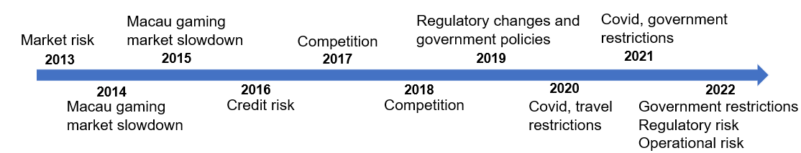

**Financial Risks:**

Market Risk:

a) Foreign exchange risk: In recent years, GEG’s foreign exchange risk arises from future commercial transactions, recognized assets and liabilities, which are denominated in a currency that is not the functional currency of different group companies. The foreign exchange risk mainly arises on the debt securities denominated in United States dollar and cash and bank balances denominated in United States dollar and RMB.

b) Price risk: In 2022, GEG is exposed to price changes in investments classified as FVOCI and FVPL on the balance sheet. If the market values of the Group's FVOCI investments had been 10% higher or lower at the end of the year, it would have resulted in a potential decrease or increase in total comprehensive income. Similarly, a 10% change in the market values of the Group's FVPL investments would have led to a lower or higher total loss for the year.

c) Interest rate risk: In recent years, GEG is exposed to interest rate risk, primarily through changes in rates affecting interest-bearing assets and liabilities. It mainly faces cash flow interest rate risk from variable-rate borrowings and fair value interest rate risk from fixed-rate borrowings.

Credit Risk: In recent years, credit risk within GEG arises from various sources, including debt instruments, deposits, loan receivables, credit exposures to customers and gaming counterparties. Moreover, the Group faces heightened risk due to the VIP gaming market's credit-driven nature and concentration risk from existing VIP gaming operators. The maximum exposure to credit risk in 2021 and 2022 is the unimpaired carrying amounts of respective financial assets.

Liquidity risk: GEG is not obviously exposed to liquidity risk since it manages and monitors liquidity through maintaining prudent ratios, conducting cash flow forecasting, and aggregating the information at Group Treasury. Sufficient cash is available to meet operational needs, maintain headroom on undrawn borrowing facilities, and comply with borrowing limits, covenants, and regulatory requirements. Surplus cash is invested in interest-bearing bank deposits and high-quality debt securities with appropriate maturities or liquidity to align with the Group's liquidity forecasts.

**Covid-19:**

In 2020 and 2021, the Covid-19 pandemic had a huge impact on the global tourism and entertainment industries. Government-imposed travel restrictions, border control measures, and quarantine requirements severely affected international travel and tourism. Galaxy Entertainment Group faced the risk of a significant decrease in customer volume and spending due to restricted travel opportunities. In 2022, GEG was still somewhat affected by the travel and quarantine restrictions. But with the lifting of travel restrictions in 2023, Covid will no longer be a major risk.

**Regulatory Risks:**

In 2022, Galaxy Entertainment Group operates within a regulatory framework set by the Macau government. Compliance with stricter regulations requires additional resources, such as assessing resource usage, conducting audits, or making changes to game designs. These extra costs can affect GEG's competitiveness and profitability. Overregulation and excessive restrictions may reduce the appeal of games and discourage potential players from participating, which could finally lead to a decline in demand for gaming products and services. Moreover, with stricter regulation, GEG may face a more complex and uncertain legal environment, which may adversely affect its business operation and financial performance.

**Operational Risks:**

In 2022, GEG gained net revenue of HK$11.5 billion, decreased 42% year-on-year, while net revenue in 2021 was HK$19.7 billion, increased 53% compared to 2020. Adjusted EBITDA in 2022 was HK$(0.6) billion, which was a huge decrease compared to HK$3.5 billion in 2021. Compared to HK$1.3 billion in 2021, net profit attributable to shareholders in 2022 was HK$(3.4) billion. Galaxy Macau is the primary contributor to Group revenue and earnings. In 2022, its net revenue was HK$7.4 billion, down 44% year-on-year. Adjusted EBITDA was HK$295 million, down 90% year-on-year. In 2022, StarWorld Macau’s Net Revenue was HK$1.0 billion, down 68% year-on-year. Adjusted EBITDA was HK$(527) million versus HK$374 million in 2021. Moreover, the combined five hotels occupancy was 31% for 2022, a large decrease compared to 47% for 2021. The above data indicate that GEG has potential risks in its operations.

**Financials Since IPO**

Galaxy Entertainment Group Limited (“GEG”) is a limited liability company incorporated in Hong Kong and has its listing on the Main Board of The Stock Exchange of Hong Kong Limited (“SEHK”). Hong Kong Stock Exchange (HKEX) carries out regulation of listed issuers and any relevant party in accordance with the listing rules. GEG went IPO in 1999 (0027.HK). However, annual reports only from 2004-2023 are available. The financial statements were prepared in accordance with Hong Kong Financial Reporting Standards (“HKFRS”) under historical cost conventions. Modifications of financial assets and financial liabilities were carried at fair value.

Sources: <https://www.hkicpa.org.hk/hksaebk/HKSA_Members_Handbook_Master/volumeII/hkas01revdec07.pdf>

<https://www.investing.com/equities/galaxy-ent-cash-flow>

<https://www.galaxyentertainment.com/en/investor/financial-reports>

<https://app.koyfin.com/fa/00000000-3c6b-403d-8336-0c36676ca980/eq-virl1f>

<https://finance.yahoo.com/quote/0027.HK/financials?p=0027.HK>

**Current Balance Sheet**

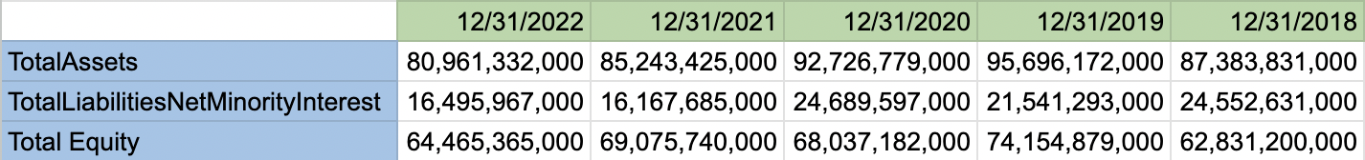

(Currency in HKD )

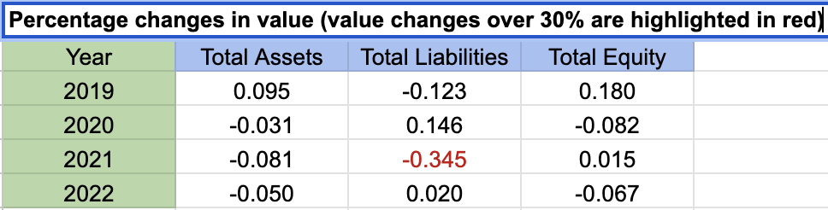

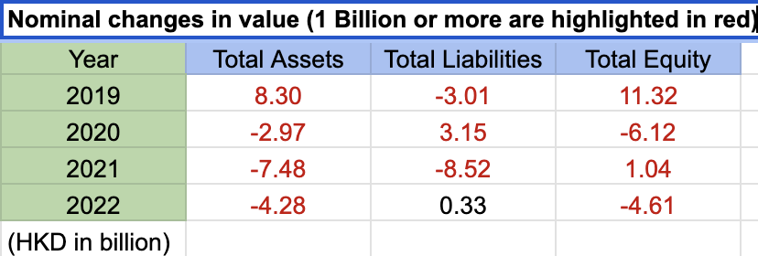

As at 31 December 2022, GEG invested 9.019 billion (11.58 billion as at 31 December 2021) in high quality debt securities recorded in its financial assets, and 3.349 billion (3.449 billion as at 31 December 2021) in listed investment of Wynn Resorts, a company that develops and operates high end hotels and casinos and its shares are listed on the Nasdaq Stock Exchange. As at the end of 2022, GEG held 5.2 million shares of Wynn Resorts, which represented approximately 4.6% of issued share capital of Wynn Resorts. The fair value of investment in Wynn Resorts was 3.349 billion, representing 4.1% of GEG’s total assets of 80.961 billion. The value of Property Plant And Equipment was 50.3 billion, representing 62% of the company’s total assets. Following that, the cash and equivalents was 16.3 billion, representing 20% of the company’s total assets.

GEG had almost 7.7 billion of trade creditors and accruals liabilities, and 7.6 billion in total debt until the end of 2022. It also had long-term lease liabilities of 433.1 million at the end of 2022. It decreased by 0.5 million from a year ago. The interest expense of lease liabilities was 16,468,000 (2021: 15,220,000).The total expenses relating to short-term leases were 7,248,000 (2021:13,697,000) and the expenses in relation to low-value asset leases were not material. During the year ended 31 December 2022, the total cash outflow for leases was 63,620,000 (2021:69,918,000).

GEG leased various offices, warehouses and equipment under non-cancellable operating leases expiring within 1 year to 29 years. The company recognised right-of-use assets for these leases. Rental receivables in following period are shown below: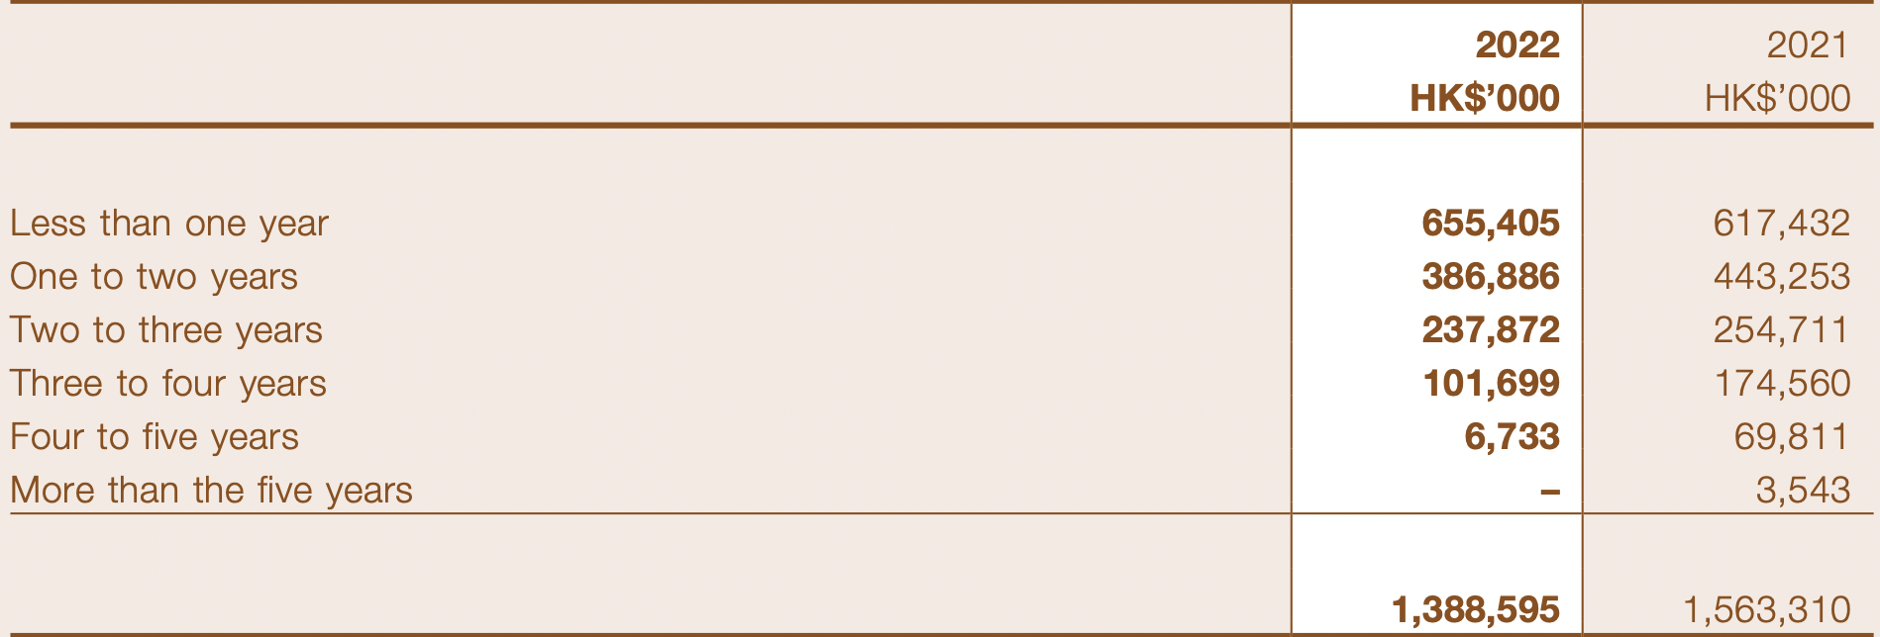

The depreciation charges of right-of-use assets for leasehold land and land use rights were 89,645,000 (2021:87,493,000), and the depreciation charges of right-of-use assets for other property, plant and equipment were 46,304,000 (2021:45,821,000).

**5 years Cash-Flow Statement**

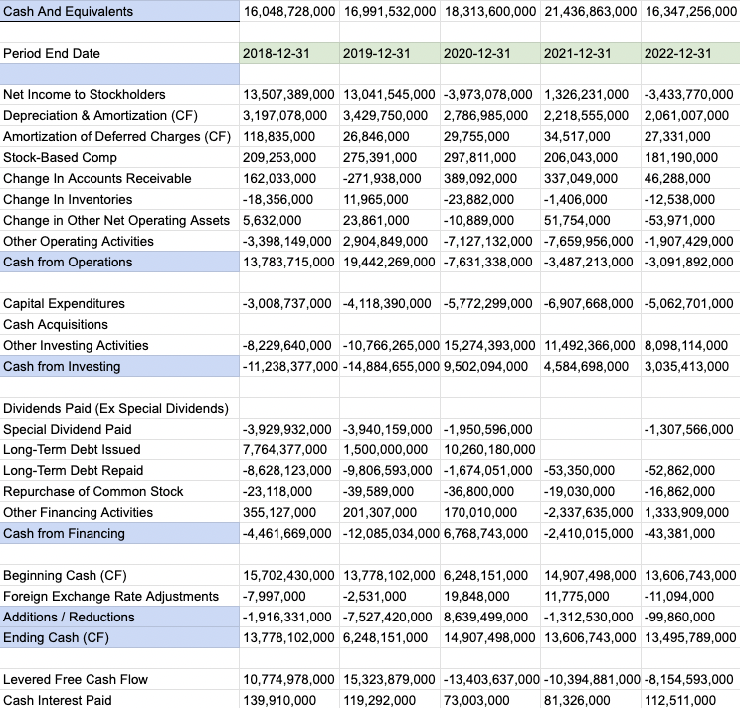

(Currency in HKD )

As of the end of 2022, The company spent approximately 3.1 billion in regular operating activities. Meanwhile, it brought in 3.04 billion through its investment activities, and further spent 4.3 million in financing activities, for a total cash outflow of 9.98 million.

**5 years income statement**

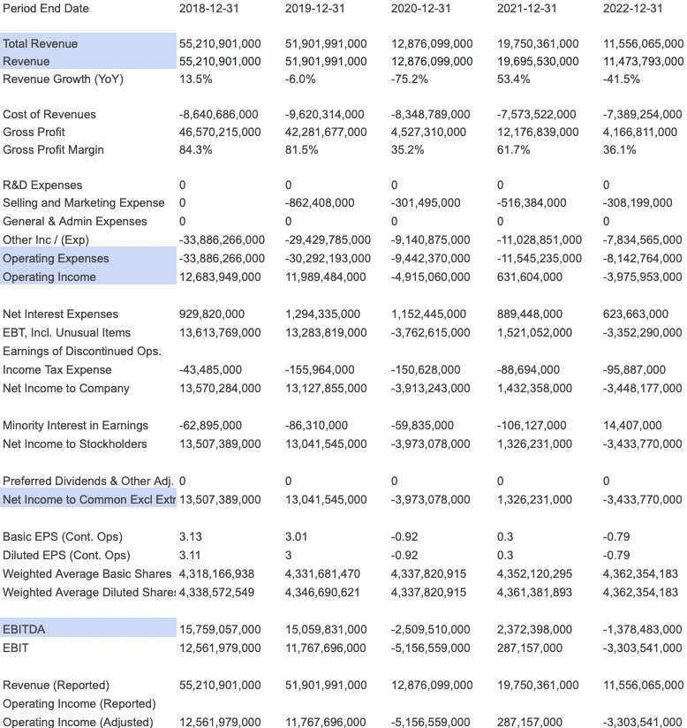

(Currency in HKD )

GEG operates through the following segments: Gaming and Entertainment and construction Materials. The Gaming and Entertainment segment manages gaming facilities and offers hospitality services. The Construction Materials segment includes manufacture and sale of construction materials

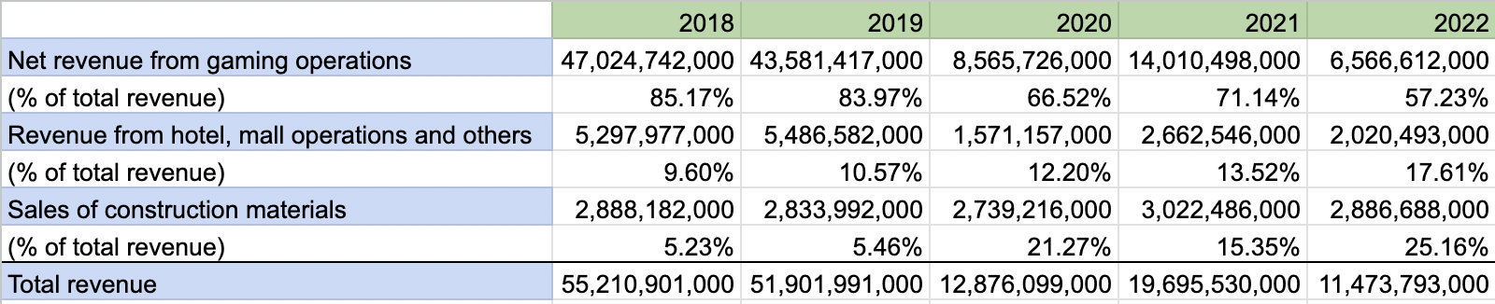

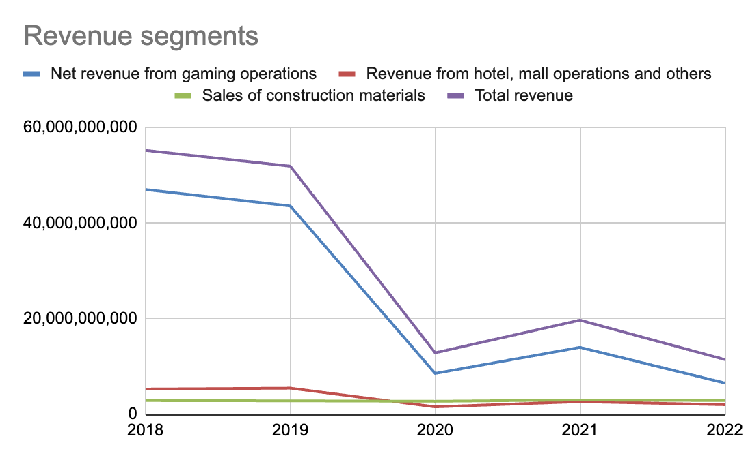

Revenue generated from the gaming operations accounts for the major part of GEG’s total revenue. However, since the beginning of 2020, COVID-19 has had a material adverse impact on GEG’s financial performance. International tourist arrivals declined dramatically due to the associated travel restrictions. According to the chart above, we noticed a sharp drop in total revenue and net revenue from gaming operations in 2020, and this decline remained unrecovered through the whole 2021 and 2022.

Clearly, 2022 was not an easy year for the company compared to the former year. As at the end of 2022, the company spent approximately 8.1 billion for operating expenses, and the EBIT was approximately -3.3 billion. The EBITDA was nearly -1.4 billion and adjusted EBITDA was -0.6 billion, showing a relatively poor profitability.

Adjusted EBITDA for GEG’s four properties (Galaxy Macau, Starworld Macau, Broadway Macau, and City clubs) are shown in the table below:

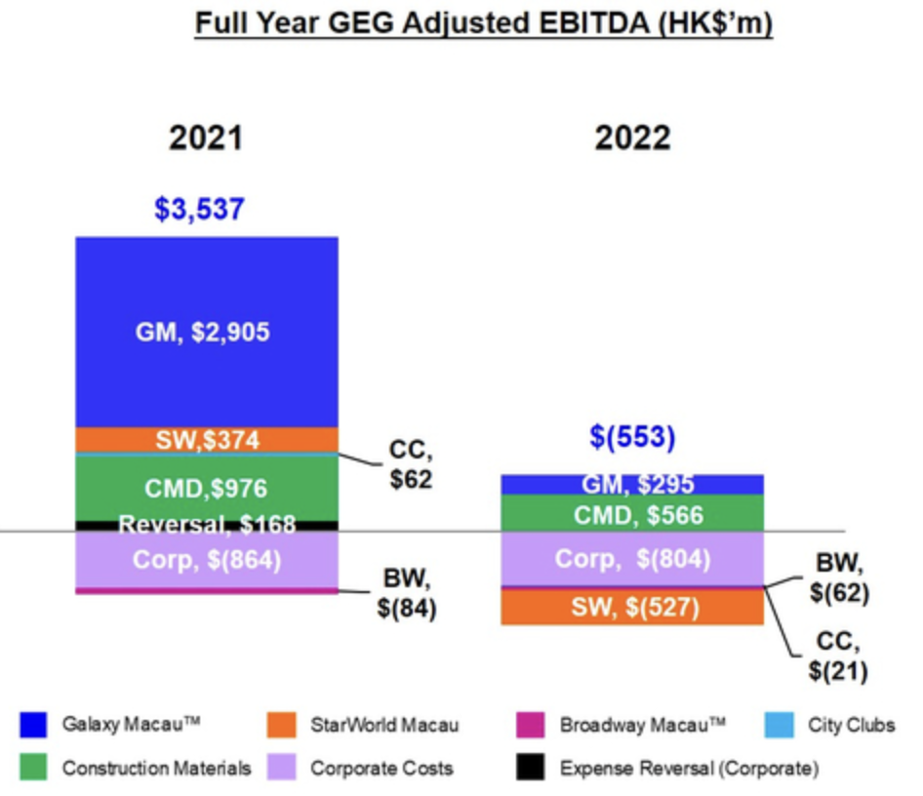

In 2022, Galaxy Macau’s Adjusted EBITDA was 295 million, down 90% year-on-year. StarWorld Macau’s Adjusted EBITDA was -527 million versus 374 million in 2021. Broadway Macau™’s Adjusted EBITDA was -62 million versus -84 million in 2021. The company played unlucky in its gaming operation, which decreased its adjusted EBITDA by approximately 33 million.

**Capitalization Requirements**

**Cash holdings (currency in HKD)**

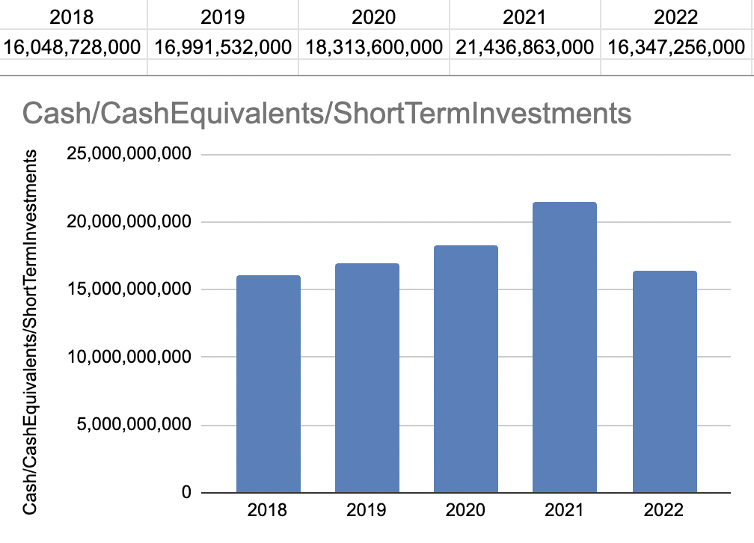

At the end of 2022, GEG’s cash holdings decreased by 23.7% over the last year. The latest balance sheet data shows that the company had liabilities of 15.3 billion due within a year, and liabilities of 1.20 billion falling due after that. The cash and short-term investment was 16.3 billion and 1.23 billion in receivables that were due within 12 months. Therefore, the company had 1.08 billion more liquid assets than total liabilities. The balance sheet remained liquid and healthy. It is unlikely the company is going to be short on cash.

**Market capitalization (currency in HKD)**

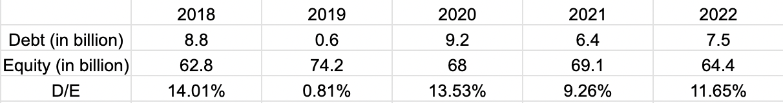

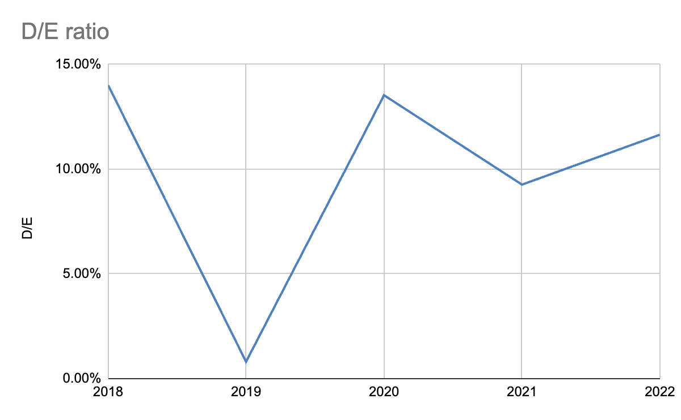

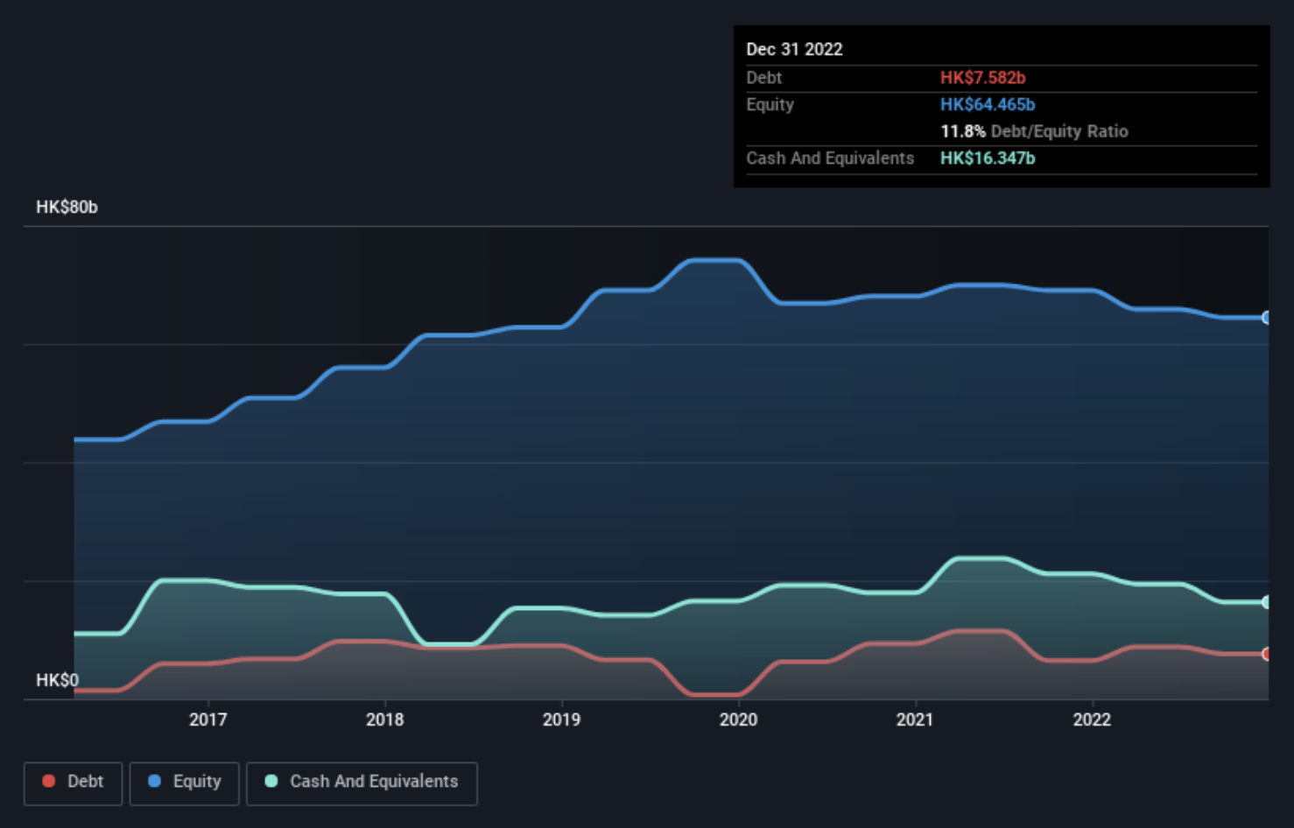

As of the end of 2022, GEG’s total debt (borrowings) was 7.6 billion that mainly comprised bank loans, and it was up from 6.48 billion a year ago. However, its balance sheet shows it held 16.3 billion in cash (cash and short-term investment), so it actually has 8.77 billion net cash, it is fair to say that the company did not have a heavy debt load.

**Ownership structure**

The largest shareholder of GEG is Lui Family Trust, with ownership of 29.35%. Capital Research and Management Company is the second largest shareholder owning 7.93% of equities, and Lui Che Woo Foundation Limited holds about 6.8% of the company stock. Additionally, insiders are the majority of holders with a total of 50.79% in shareholdings. The institutional holders are the second largest holders with 23.57% shareholdings.

**Break-even Analysis**

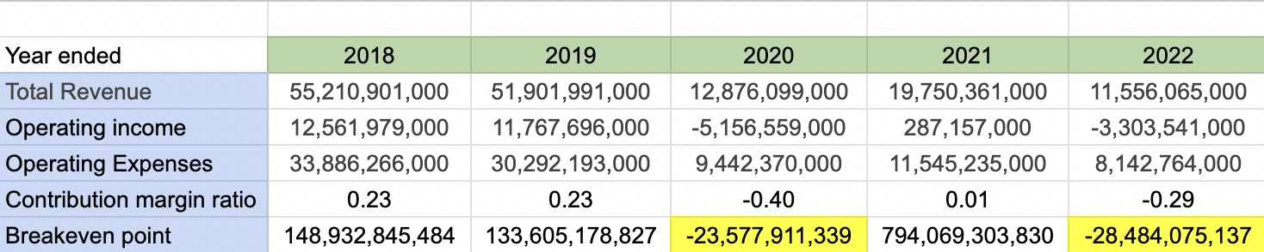

GEG had negative break-even points in both 2020 and 2022, which implies that the company has not generated sufficient revenue to cover its costs, resulting in operating losses. Noting that the company had a 1.4 EBITDA loss and a 3.4 billion accounting loss (net income loss) in 2022 over the last year, it may need to raise more capital given the company had net cash of 8.77 billion until it reaches break-even point.

**Cash Flow Projection**

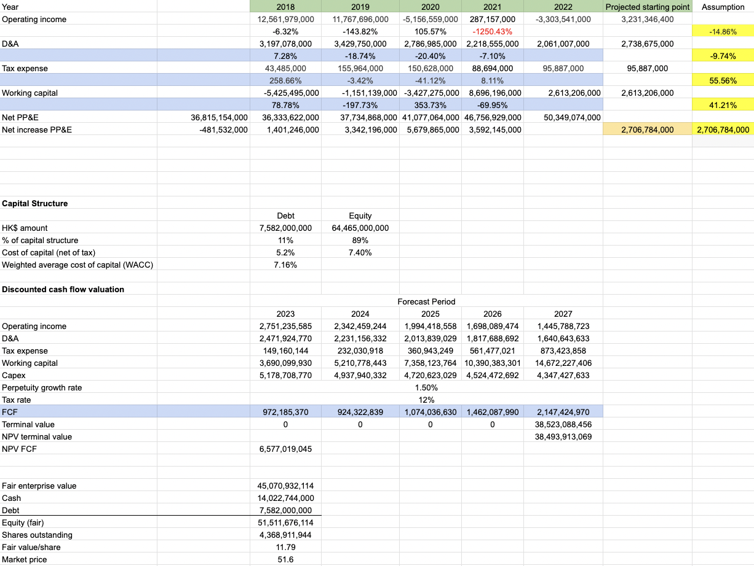

**Industry Multiples**

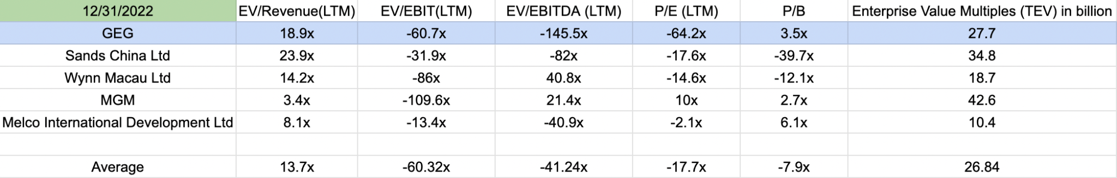As of the end of 2022, GEG had negative EBIT and EBITDA, further leading to negative EV/EBIT and EV/EBITDA multiples which are non-meaningful. In this scenario, negative EV/EBIT and EV/EBITDA multiples would imply a negative enterprise value, which is not practically feasible. Similarly, since GEG reported losses in earnings, the P/E ratio of -64.2x is non-meaningful either. As for P/B ratio, GEG had a higher index of 3.5x, indicating that the company is overvalued. With this in mind, It had a higher EV/Revenue ratio, indicating that the market valued the company relatively higher compared to its revenue. A higher enterprise value suggested that GEG as having greater potential or value compared to the average listed companies.

Despite the current losses, investors may believe that the company has strong growth prospects, which could justify the higher EV/Revenue ratio and enterprise value.

**Stock Data Collection**

**1.** **Stock Price Since IPO**

a. Original Company Valuation at IPO:

Listed on the Hong Kong Stock Exchange (stock code: 0027.HK).

During its IPO in 2004, Galaxy Entertainment Group had a valuation of approximately HKD 108 billion (around USD 13.9 billion at that time).

b. IPO Share PRICE

IPO: $0.7

Current: $6.73 (June16, 2023)

c. Stock Price growth Since IPO

Galaxy Entertainment's stock price has generally shown growth over the years, albeit with periods of volatility due to various market and industry factors. It has experienced fluctuations in its stock price over time.

Two peak points:

a. 01/14/2014 76.3 HKD

The revenue had grown 8.63% ($9.25 B) in 2014. It showed sustainable growth in the past six years (From 2009 -2014).

Annual revenue below:

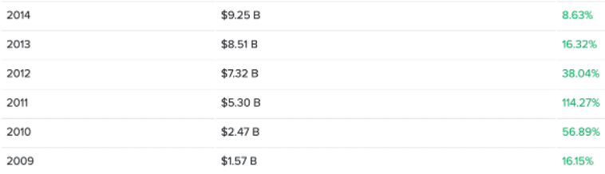

b. 04/01/2021 70.00 HKD

The revenue had dropped from 2018 to 2020 for three years, until in 2021, the revenue has grown 52.07% ($2.52B).

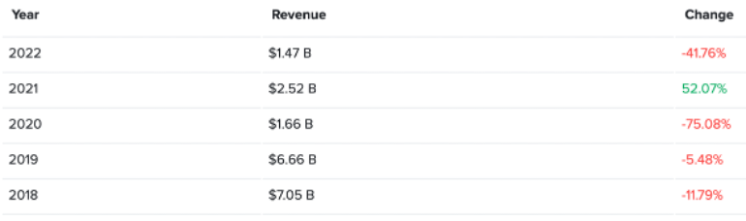

d. Year by Year Stock Price Highs and Lows

Stock Price Highs

**01/14/2014 76.3 HKD (Highest)**

03/01/2018 71.25 HKD

04/01/2021 70.00 HKD

04/01/2023 55.50 HKD (This year)

Stock Price Lows

**01/10/2008 0.56 HKD (Lowest)**

09/01/2015 19.70 HKD

05/01/2023 48.55 HKD (This year)

The stock price is maintaining at 52.25 HKD in past 6 months.

e. Stock Split Analysis (If there is)

N/A

**2.** **Stock Price Moving Average Analysis**

**P/E = -66.03**

Stock Price = 52.17 HKD

Diluted EPS = -0.790



**Negative earnings.**

Even it’s established companies experience down periods, which may be due to environmental factors that are out of the company's control.

**3.** **Price/Earning Ratio 3-5 Years**

**Compare - with top 2 Competitors**

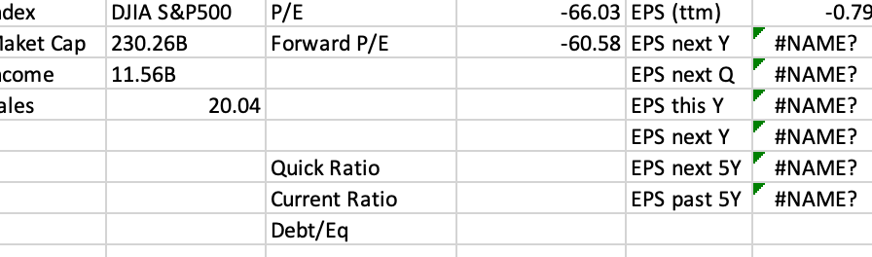

**Index Performance**

From the code by python

Writing program code in Python starts by referencing key packets and setting start and end times.

Listed on the Hong Kong Stock Exchange (stock code: 0027.HK).

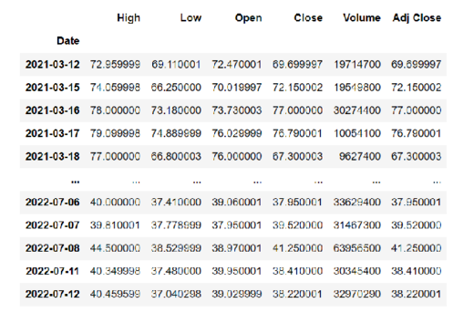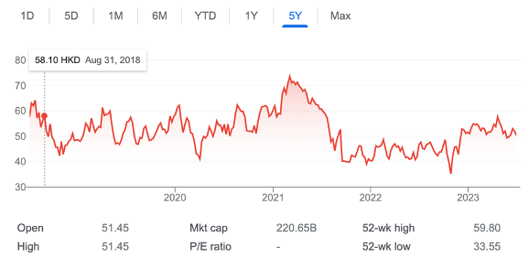

Galaxy Entertainment's stock price has generally shown growth over the years, albeit with periods of volatility due to various market and industry factors. It has experienced fluctuations in its stock price over time.

**Hong Kong Hotel Stock Index**

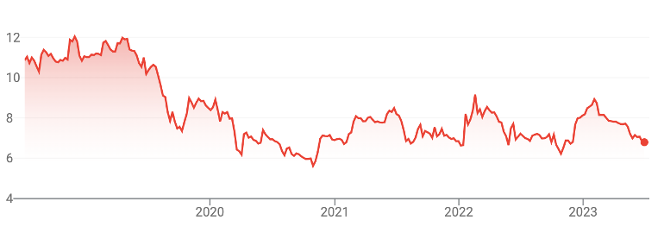

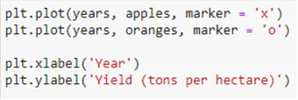

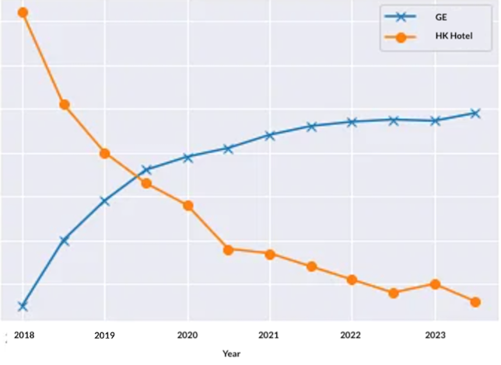

**HK Competitor Index**

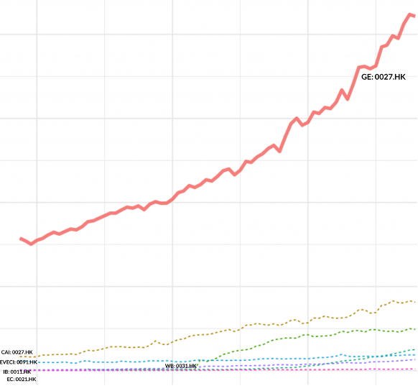

**US Hotel Stock Index**

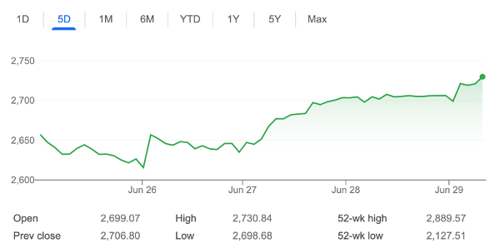

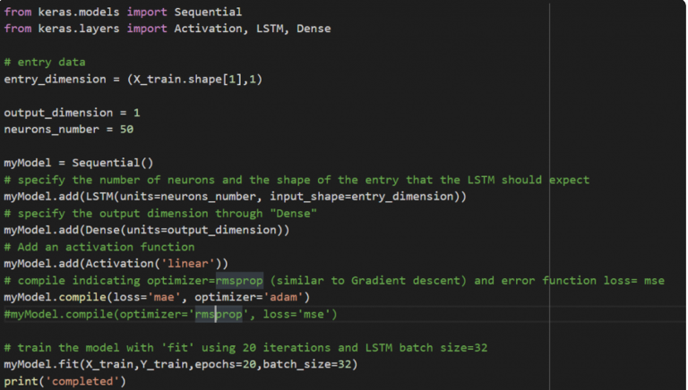

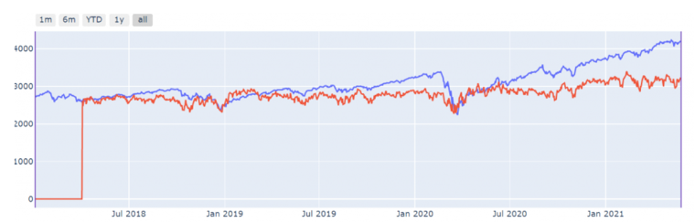

**S&P 500 index:**

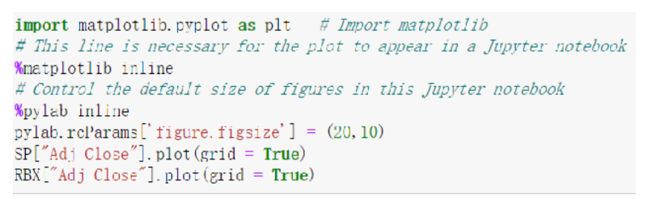

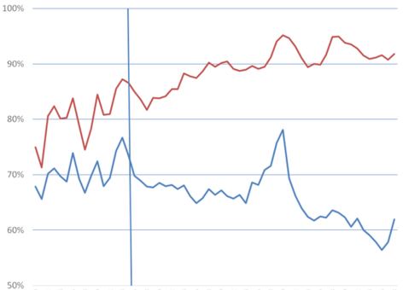

Using the Python drawing tool, the data images of S&P500 and Galaxy Entertainment are obtained. The comparison shows that the S&P500 has a small fluctuation and the overall trend is stable, while The Galaxy Entertainment has a large change from December 2022 until now.

**Market Research**

**Who are the Target Customers for Company**

The target customers for the company include travelers, gamblers, and VIPs.

**Travelers:** The company focuses on attracting visitors to Macau, particularly from Mainland China. Before the Covid-19 pandemic, Mainland Chinese tourists accounted for 71% of all visitors to Macau. As of the lunar new year break in 2023, the number of Mainland Chinese visitors has recovered to 30% of the same period in 2019. There has also been a noticeable increase in younger and family-oriented travelers, indicating a growing market segment for the company to target. Overnight visitors, who constituted nearly half of the total visitation in 2019, are also an important target group for the company.

**Gamblers:** The company targets both young and old gamblers. The age groups of young gamblers (26-45 years old) and old gamblers (above 46 years old) are considered. The company recognizes that 44% of gamblers in 2019 were between 26-45 years old. Additionally, a significant percentage of both older (74%) and younger gamblers (63%) are likely to revisit Macau within six months, indicating their potential as target customers.

**VIPs:** The company focuses on high rollers and VIP guests who are willing to spend large sums of money on gambling and expect premium services and privileges. The company identifies two key categories: VIPs recruited by gambling intermediaries and direct VIPs introduced by gambling operators. The company's VIP business has already established a strong foundation with a significant market share. The high-end middle-market business segments are also recognized as having substantial development potential and are expected to contribute to the company's revenue growth.

**How do they acquire Targeted Customers**

**Travelers:** To attract travelers, the company employs various strategies. Marketing efforts are specifically targeted towards mainland Chinese tourists to increase the number of visitors from this market segment. The company also offers attractive accommodation options, entertainment facilities, and promotions to encourage overnight stays. GEG has established new shopping areas with international luxury brands, along with tropical gardens, artificial beaches, theaters, water parks, and amusement parks. As GEG continues to expand its non-gaming businesses, including dining, shopping, and exhibitions, and expands its hotel and suite facilities, it aims to attract more tourists to stay in Macau. They are also exploring the potential of Hengqin and attracting more mainland Chinese tourists through its development. Additionally, GEG has benefited from the opening of major transportation infrastructure, such as the Hong Kong-Zhuhai-Macau Bridge, which has significantly increased the number of tourists to Macau.

**Gamblers:** The company caters to both new and regular gamblers by providing a variety of gambling experiences and amenities. They upgrade casinos and introduce new entertainment facilities to appeal to young gamblers and create a modern gambling environment. They also compete in various areas, such as advertising, expanding facilities, and improving service quality, to attract and retain customers. GEG have a strong presence and brand recognition within the market.

**VIPs:** The company offers VIP gaming services that provide credit services through rolling chips and cash chips, instead of cash chips only, attracting customers who prefer VIP-level gambling experiences. They have a strong customer base and leading market share, which helps attract more VIPs based on their reputation and exclusive services. In non-gaming industry, they also present superior privileges to esteemed members, aiming to make it easier for members to enjoy high-quality products, services, and experiences. They carefully select various global treasures and customize gifts tailored to each individual, along with considerate and attentive concierge services.

**Collaborations:** The company leverages collaborations with various specialized companies to acquire targeted customers. These collaborations involve introducing advanced technologies like IMAX with Laser systems, organizing cultural and entertainment events, launching luxurious hotel brands, and providing convenient services such as battery swap stations and 3D cinemas. By offering a diverse range of entertainment activities, the company aims to attract a wider customer base and enhance their overall business operations.

**What type of marketing does the company do to increase their brand recognition?**

**Social Media:** Galaxy Entertainment Group effectively utilizes social media platforms such as Facebook, Weibo, and LinkedIn to enhance brand recognition and engage their audience. They have amassed an impressive following, with 514K followers for Galaxy Macau on Facebook, 54.7K followers for Galaxy Macau on Weibo, and 31K followers for Galaxy Entertainment Group on LinkedIn. Actively maintaining these profiles allows them to foster a vibrant community and establish valuable connections with their customers. Through these platforms, they share regular updates, promotions, and captivating content related to their properties and offerings. By leveraging social media, Galaxy Entertainment Group aims to create a strong sense of community, generate excitement around their brand, and forge meaningful relationships with their customers.

**Partnerships and Collaborations:** GEG engages in strategic partnerships and collaborations with renowned companies and brands to enhance brand recognition and expand their market reach. By collaborating with various industry leaders, GEG can offer unique and innovative experiences to customers. For instance, their collaboration with IMAX enables them to provide premium cinematic experiences, while their partnership with Accor S.A. resulted in the creation of a loyalty program that offers exclusive benefits and rewards to customers. Therefore, these partnerships and collaborations play a vital role in GEG's marketing efforts to increase brand recognition.

**Environmental Sustainability:** GEG places a strong emphasis on environmental sustainability, implementing initiatives to minimize their ecological footprint. They have developed comprehensive sustainability programs and practices that cover various aspects of their operations, including energy conservation, renewable energy, waste management, greenhouse gas emissions, and water conservation. They have received awards such as the Energy Saving Concept Award and Green Hotel Awards for their hotels, recognizing their commitment to sustainability.

**Community Engagement:** GEG actively engages with the local community through initiatives, sponsorships, and donations. They support cultural and entertainment activities and contribute to community development. Additionally, they make donations with their own foundations to various causes and organizations, demonstrating their commitment to social responsibility. Through these efforts, GEG not only promotes their brand but also strengthens their relationship with the community and builds a positive reputation.

**Brand positioning**

**Marketshare**

**VIP Business:** Galaxy Entertainment Group has a strong foundation in the VIP business in the Macau market and has established good cooperative relationships with multiple intermediaries. For the years of 2020-2022, Galaxy Entertainment Group held the first position in market share for VIP business, accounting for about 28%.

**Single Gambling Table Profitability:** GEG consistently ranks among the industry's top performers in terms of net profit per table, demonstrating its ability to effectively leverage table resources and achieve remarkable profitability.

**Non-VIP Gaming Business:** From 2020-2022, GEG's Non-VIP gaming business generated a noteworthy revenue, capturing a market share of 18.7% and securing the second position, following Sands China.

**Non-Gaming Business:** Alongside its gaming ventures, GEG owns and operates eight luxury hotels, ranking second in the industry in terms of room capacity. Additionally, GEG operates numerous dining venues, retail properties, conference and event spaces, as well as entertainment facilities like the Grand Resort Deck. The company's strategic investments in the MICE market further emphasize its commitment to diversification.

However, compared to Las Vegas, there is still significant room for development in the non-gaming business, and the revenue structure is expected to continue improving. In 2020, the non-gaming revenue accounted for 14.96% of the total revenue for Macau's gaming companies, while in Las Vegas, it was 64.5%. There is a significant difference in the revenue structure between the two regions. Nevertheless, there is a positive trend indicating an increasing proportion of non-gaming revenue in GEG's total income. With the ongoing construction of Galaxy Macau Phase 3 and Phase 4, GEG anticipates expanding its non-gaming facilities and further boosting their contribution to overall revenue.

**Company Rankings from Industry Organizations**

Based on the Forbes Global 2000 ranking for 2023, Galaxy Entertainment Group holds the #1770 position. The company has established itself as a prominent player in the Macau casino industry, with a particular focus on the VIP segment. Through strategic partnerships and a strong market share, Galaxy Entertainment Group has become a leading resorts, hospitality, and gaming company. One of the key factors contributing to the company's success is its brand positioning, which is characterized by trust, reliability, quality, and excellence. This reputation as a reputable and trustworthy brand has been reinforced by their high rankings and market share, indicating their ability to consistently deliver high-quality products and services.Customer satisfaction is another area where Galaxy Entertainment Group excels. It is widely recognized as the second-best entertainment destination in Macau, boasting an impressive customer rating of 4.9/5. This high level of satisfaction can be attributed to the company's dedication to innovation and adaptability, allowing them to stay ahead of evolving customer preferences and maintain their leading market position.

Galaxy Entertainment Group differentiates itself by offering a comprehensive entertainment experience that goes beyond just gaming. They provide a range of non-gaming amenities and luxury hotel facilities, creating a well-rounded experience for their customers. In addition to their business pursuits, Galaxy Entertainment Group is committed to fulfilling its social responsibilities and actively contributes to the development of Macau as a "World Center of Tourism and Leisure." This dedication to the local community further enhances their reputation and strengthens their position in the market.

**SWOT Analysis**

**Strengths**

**Operational Capacity:** Galaxy Entertainment is a leading gaming and entertainment company in Asia, operating multiple flagship hotel properties such as StarWorld Macau, Broadway Macau, and Galaxy Macau. These properties offer a luxurious lifestyle and leisure experience for customers. The company boasts a large inventory of rooms, suites, and villas across its hotels, providing a strong operational capacity to accommodate a wide range of guests. Additionally, Galaxy Entertainment focuses on manufacturing and distributing construction materials in Macau, Hong Kong, and China, further diversifying its operational capacity.

**Leading Position in Land Reserves:** Galaxy Entertainment Group holds the top position in the industry for land reserves. The expansion of its projects in Hengqin, in collaboration with the Guangdong Zhuhai Hengqin New Area, is expected to drive the development of non-gaming businesses. The Hengqin project aims to create a world-class resort and tourist destination with low-density structures, complementing the high-density projects in Macau. This leading position in land reserves empowers Galaxy Entertainment to explore new business opportunities and sustain its growth trajectory.

**Stable Ownership Structure and Experienced Management:** Galaxy Entertainment maintains a stable ownership structure, with Dr. Lui Che Woo serving as the Chairman and Dr. Lui Yiu Tung as the Vice Chairman. The company has established wholly-owned subsidiaries and joint ventures in various locations, showcasing its diversified business operations. With an experienced management team that possesses extensive knowledge of the gaming and hotel industry, as well as a deep understanding of Macau's culture and market dynamics, Galaxy Entertainment is well-positioned to drive strategic initiatives and navigate industry challenges.

**Weaknesses**

**Geographic Concentration:** The company’s limited geographical reach could be an area for improvement as it may hamper its financial position, restrict it from gaining more customers and increase its Revenue. Though it has operations in Hong Kong and China, Galaxy Entertainment generates 87.1% of its revenue from Macau. Thus, the company’s financial results are subject to general regulatory, legal, economic, demographic, competitive, and other conditions in the country. Changes in any of these conditions may negatively impact the results of operations.

**Declining VIP Business:** Galaxy Entertainment Group has experienced a decline in the proportion of its VIP business revenue. The anti-corruption policies implemented by the Chinese government between 2014 and 2017 had an impact on the VIP business of Macau's six casino operators, leading to a decrease in the proportion of VIP revenue as a percentage of total gross revenue. In 2017, Galaxy Entertainment Group's VIP business revenue accounted for 56% of its total revenue, representing a 17% decrease from 2014. However, despite the decline, Galaxy Entertainment Group still maintains a higher proportion of VIP business compared to the industry average, second only to Wynn Macau.

**Opportunities:**

**Business Expansion:** The company is taking various strategic initiatives to drive its business growth. In March 2021, the company and Accor entered into a partnership to launch the Raffles brand in Macau. Under the agreement, the company to develop an exclusive all-suite tower Raffles at its integrated resort Galaxy Macau. The new tower to feature approximately 450 suites and is expected to open by the end of 2021. In November 2021, Galaxy Broadband partnered with OneWeb to deliver transformational satellite communication to mining companies. It has provided with terrestrial wireless connectivity and enterprise satellite broadband services. This new addition enhances the company luxury hotel portfolio at the Galaxy Macau.

**Positive Outlook for the Travel and Tourism in Hong Kong:** The company is likely to benefit from the positive outlook for T&T industry in Hong Kong as the company operates, owns and leases hotels in Hong Kong. According to World Travel & Tourism Council (WT&TC), direct contribution of T&T industry to the country’s GDP is expected to reach HKD 175 billion in 2028. Moreover, the industry's total contribution to the country’s economy is expected to reach HKD634.5 billion in 2028. The visitor exports are also expected to increase by 4.1% per annum during the forecast period to reach HKD 461.9 billion in 2028. In addition, rise in investments to HKD70.6 billion in 2028 is likely to boost activities within the T&T industry in Hong Kong.

**Expanding Business Footprint in Cotai:** The company has successfully expanded its business footprint in the Cotai region of Macau, operating flagship properties such as the Galaxy Macau, Broadway Macau, and StarWorld Hotel. Ongoing projects, including the development of the Galaxy Macau's third and fourth phases, will further expand the company's presence in the area and offer a wide range of facilities and services to cater to different market segments.

**Development of World-Class Resort in Hengqin:** The company has invested CNY 10 billion to develop a world-class resort in Hengqin, a region in Zhuhai, Guangdong province, China. This project is expected to boost the company's non-gaming business and take advantage of the growing tourism opportunities in the area.

**Advantage in Land Resources:** Galaxy Entertainment Group holds significant land resources, particularly in the Hengqin area, which gives it a competitive advantage for future gambling license bidding. With a focus on non-gaming projects and the completion of various phases, the company is well-positioned to capitalize on its land resources and benefit from the diversification of the industry in Macau.

**Infrastructure Development and Collaboration**: Several infrastructure projects are underway, improving travel convenience to Macau. The opening of the Guangdong-Macau Cooperation Passage and the completion of the Hong Kong-Zhuhai-Macau Bridge have facilitated transportation between Macau, Hong Kong, and mainland China. The extension of the Macau Light Rail to Hengqin is expected to be completed in 2024, further enhancing connectivity and supporting the influx of visitors to Macau. The Cotai area offers opportunities for joint projects between Macau's casino operators and Hengqin, promoting diversified and collaborative development.

**Threats**

**Credit Risks - Casino:** The company’s gaming business is based on unsecured credit and cash of its properties. The company grants credit to table games players, slot players, and high-stakes players typically. It extends a good amount of credit to table game player than slot players and high-stake players. High-end gaming is riskier than other gaming forms, and changes in gaming results attributable to high-end gaming could have a significant effect on the company’s cash flow and revenues. It offers credit to those players with good playing skills and whose financial resources are warrant, in the opinion of management. In the case of uncollectible receivables, it could have severe impact on its earnings.

**Travel Visa Policies:** Changes in travel visa policies, particularly related to Chinese passport holders transiting through Macau, pose a threat to the company. In 2008, the Macau government initially reduced the permitted stay duration for Chinese passport holders from 14 days to 7 days. In July 2015, the policy was relaxed back to the previous 14-day stay duration. As the visa policy plays a crucial role in attracting Chinese tourists to Macau, any restrictions or alterations in the policy can have a significant negative impact on the company's operations and financial performance. It creates uncertainty and potential barriers for Chinese tourists, which could result in reduced visitation to Macau and subsequently impact the company's revenue from the tourism and gaming sectors. Moreover, during the COVID-19 pandemic, group tour visas and individual tourist visas were temporarily suspended starting from January 2020 and resumed in August 2020. the ongoing COVID-19 pandemic has further increased uncertainty and potential risks as travel policies and restrictions remain subject to change. Monitoring and adapting to visa policy changes are crucial for mitigating potential negative impacts on the company's business.

**Chinese Government policy:** Chinese government policies, such as strict foreign exchange controls and regulations on gambling promotion, pose significant threats to the gambling industry in mainland China. These policies limit the provision of gambling credit services, make debt collection difficult, restrict customer acquisition, and expose the industry to regulatory risks. The absence of legal recognition and protection for gambling loans further exacerbates these challenges, putting the stability and profitability of the industry at risk.

ChinesePolicy: 1. Considering China's strict foreign exchange controls (with an annual limit of $50,000 USD per person), there is a need for individuals to provide gambling credit services to customers. 2. Promoting gambling in mainland China is also prohibited, but intermediaries can reach out to customers through their personal networks and bring them to collaborate with the casinos. 3. Since gambling loans are not legally recognized and protected in mainland China, it is very challenging for casinos to recover debts. However, intermediaries, having personal connections with customers, have channels to collect these debts.

**Online Theft and Hacking Risks:** The company relies on information technology for its business transactions, including management software, stock system, accounting software, online booking engines, email, and internet access. These technologies expose the company to the risks of online identity theft and hacking. The security measures in place for the company's online portal operations are diverse but still susceptible to unauthorized attacks, such as break-ins and denial-of-service attacks, as well as other disruptions caused by internet usage. The effectiveness of the company's internet security depends on the quality of its hardware and software, which may not fully safeguard the portal against unauthorized attacks, leading to system failures. Such security breaches pose a threat to the security of stored data and its transmission through the company's computer systems.

**Smoking Bans:** The comprehensive smoking ban implemented in Macau's gaming areas and VIP rooms limits smoking opportunities for customers, which can affect the overall gaming experience and potentially reduce revenue.

**Mergers and Acquisitions**

**Acquisition**

| # | Date | Transaction | Purchase Price (HKD) |
| --- | --- | --- | --- |
| 1 | 05/05/2013 | Grand Waldo Complex | $3.25 Billion |
| 2 | 08/11/2006 | Tarmac Asphalt Hong Kong Limited (‘‘Tarmac Asphalt’’) | $87.4 Million |
| 3. | 07/22/2005 | Galaxy Casino | $18.4 Billion |

**1. Grand Waldo Complex:** Galaxy Entertainment made a significant acquisition by purchasing HKD 100% of the properties comprising the Grand Waldo Complex. The transaction was valued at $3.25 billion and involved acquiring the assets from a subsidiary of Get Nice Holdings, Ltd. The acquired complex includes a casino, spa, and a 342-room hotel, which Galaxy Entertainment now operates. This acquisition served to expand Galaxy Entertainment's presence in the Macau Hotel and Casino market, particularly in the Cotai area where it is located adjacent to Galaxy Macau™. By increasing its casino permitted landbank in Cotai, this acquisition played a crucial role in supporting Macau's vision of becoming a world-renowned center for tourism and leisure.

During this acquisition, Dr. Lui Che Woo served as the leader of Galaxy Entertainment Group, while HUNG Hon Man held the position of Chairman at Get Nice Holdings, Ltd. Additionally, Robert Drake, the Group Chief Financial Officer at Galaxy Entertainment, and. CHAM Wai Ho, Anthony，Deputy Chairman of Get Nice Holdings, Ltd, were responsible for merger and acquisition activities during this period.

After acquiring the Grand Waldo Complex, Galaxy Entertainment embarked on a comprehensive renovation, leading to its rebranding as Broadway Macau. Notably, Broadway Macau achieved a commendable financial performance, with an Adjusted EBITDA of $84 million in 2021. Moreover, the venue received prestigious accolades in recognition of its dedication to environmental sustainability. It was honored with the Silver Award in the 2021 Macao Green Hotel Award and also excelled in the CEM Energy Saving Contest 2022, further affirming its commitment to energy conservation and responsible practices.

**2. Tarmac Asphalt Hong Kong Limited:** Galaxy Entertainment completed the acquisition of Tarmac Asphalt Hong Kong Limited, purchasing 80% of the equity interest for HKD 87.4 million. This strategic acquisition allowed Galaxy Entertainment to increase its ownership stake in Tarmac Asphalt from 20% to 100%, transforming it into a wholly owned subsidiary. The acquisition took place through a reverse merger with K. Wah Construction Materials, resulting in the combined entity trading on the HKG Stock Exchange under the ticker symbol 0027 in 2005. By acquiring Tarmac Asphalt, Galaxy Entertainment gained several advantages. Firstly, it obtained the capability to construct its own hotel and expand its existing land holdings. This increased control over the development process, allowing Galaxy Entertainment to shape its properties according to its vision. Additionally, Tarmac Asphalt held a prominent position in the reserve land industry, positioning Galaxy Entertainment to benefit significantly from the expansion of the Hengqin project. The development of Hengqin further drives the growth of Galaxy Entertainment's non-gaming business operations.

**3. Galaxy Casino:** The acquisition process has been successfully completed, with Canton Treasure Group Ltd., a wholly owned subsidiary of the Company, acquiring a significant stake in Galaxy Casino, S.A. Specifically, Canton Treasure Group now holds 88.1% of the voting shares and 97.9% of the economic interest in Galaxy Casino. The purchase price for this transaction amounted to HKD $18.4 billion. Following the acquisition, the Group made a strategic decision to change its name to "Galaxy Entertainment Group Limited" and realigned its focus towards gaming and entertainment. As a result, the company's primary emphasis shifted to these sectors. Currently, the casino market continues to be the primary revenue generator for Galaxy Entertainment Group compared to other business sectors. The company recognizes the ongoing significance and potential of the casino industry and remains dedicated to maximizing revenue and growth opportunities within this domain.

**Investments**

| # | Date | Transaction | Purchase Price | Type |
| --- | --- | --- | --- | --- |
| 1 | 03/23/2018 | Wynn Resorts | $927.5 Million (USD) | 2PO |
| 2 | 07/25/2015 | Société Anonyme des Bains de Mer et du Cercle des Étrangers à Monaco (“SBM”) | $364.3 Million (HKD) | PIPE |

**1. Wynn Resorts:** Galaxy Entertainment Group successfully acquired approximately 4.9% of the issued share capital of Wynn Resorts, Limited. This strategic acquisition involved purchasing 5.3 million newly issued shares at a price of $175 per share, resulting in a total transaction value of USD $927.5 million. Wynn Resorts, a prominent global hospitality and gaming company listed on the Nasdaq Stock Exchange (stock code WYNN), specializes in the development and operation of high-end hotels and casinos. The agreement for the acquisition was signed between Francis Lui Yiu Tung, the Executive Director of Galaxy Entertainment Group, and Matt Maddox, the President of Wynn Resorts. It is noteworthy that Dr. Lui Che Woo was the leader of Galaxy Entertainment Group at the time of this acquisition. As of December 31, 2020, Wynn Resorts reported a dividend income of HKD $28.2 million and a market value of HKD $4.55 million.

**2. Societe Anonyme des Bains de Mer et du Cercle des Etrangers a Monaco ("Monte-Carlo SBM"):** Galaxy Entertainment strategically invested in Monte-Carlo SBM, a renowned company known for its operation of luxury hotels and casinos. The purchase price for this acquisition amounted to HKD $364.3 million. Galaxy Entertainment and Monte-Carlo SBM entered into a mutual commitment to enhance their respective businesses and brands. They also agreed to collaborate on the development and operation of entertainment businesses, particularly Integrated Resort projects, in the Asia-Pacific region. This collaboration extends to identifying and pursuing opportunities in countries such as Japan, where the integrated resort industry is emerging. Mr. Michael Victor Mecca became a part of the Group in 2009, initially serving as President and Chief Operating Officer before assuming the role of President in September 2015. Prior to his tenure with Galaxy Entertainment, Mr. Mecca had also served as a board member of Société Anonyme des Bains de Mer et du Cercle des Étrangers à Monaco ("SBM") from September 2015 to September 2021. By making this acquisition, Galaxy Entertainment aimed to explore more business opportunities in overseas markets.

**Joint Venture**

| Date | Joint Venture | Details |
| --- | --- | --- |
| 04/24/2023 | IMAX | A joint venture has been established to introduce two new, state-of-the-art IMAX with Laser systems in Vietnam. |
| 02/10/2023 | AGTech | A joint venture has been formed to organize cultural and entertainment activities and shows in Macau. |
| 11/23/2021 | OneWeb | A joint venture has been established to provide transformational satellite communication services to mining companies. |
| 03/15/2021 | Accor | Accor S.A., a French multinational hospitality company, and Galaxy Entertainment Group (GEG) have announced a collaboration to launch the Raffles brand in Macau. The joint venture aims to develop a luxurious all-suite Raffles hotel within Galaxy Macau, an integrated luxury resort. The new Raffles at Galaxy Macau will feature approximately 450 suites and draw inspiration from a modern palazzo. This partnership between Accor and GEG seeks to bring a new level of sophistication and refinement to the vibrant city of Macau. |
| 02/22/2020 | KL | A joint venture has been formed to establish a battery swap station for electric motorcycles in the team member motorcycle parking lot at Galaxy Macau. |
| 12/15/2011 | UA | A joint venture has been established to open Macau's first 3D cinema named "UA Galaxy Cinema." This initiative aims to provide convenience for Macau residents and tourists. |
| 11/02/2010 | Extreme Network's Ethernet | A joint venture has been formed to provide reliable connectivity, mobility, and convergence services at Galaxy Macau. |